dk;kZy;& jktdh; mPp ek/;fed fo/kky; tkylw ukud ¼Msxkuk½
dzekad &jkmekfo@tkuk@laLFkk&1@2019@37 fnukad 31-05-2019
&%dk;kZy; vkns”k%&
jktdh; mPp ek/;fed fo/kky; tkylw ukud ds dk;kZy; vkns”k dzaekd jkmekfo@tkuk@fnukad 24-12-2019 }kjk fo/kky; esa dk;Zjr leLr deZpkjh;ksa@vf/kdkjh;ksa ds lsok iqfLrdk esa ,d o’kZ dh mikftZr vodk”k tksMus dh Lohdfr iznku dh tkrh gSA
dz l | deZpkjh@vf/kdkjh dk uke | Ikn | vof/k | mikftZr vodk”k fnol | fo”ks’k fooj.k
1 | Jh psukjke | O;k[;krk | 1-1-19 ls 31-12-19 | 15
2 | Jh yq.kkjke csfuoky | O;k[;krk | 1-1-19 ls 31-12-19 | 15
3 | Jh Jo.kdqekj fcLlq | O;k[;krk | 1-1-19 ls 31-12-19 | 15
4 | Jh guqeku pkS/kjh | O;k[;krk | 1-1-19 ls 31-12-19 | 15
5 | Jh vt;dqekj ;kno | O;k[;krk | 1-1-19 ls 31-12-19 | 15
6 | Jh ujlhjke PkkS/kjh | Ok v/;kid | 1-1-19 ls 31-12-19 | 15
7 | Jh dj.k flga jRuq | Ok v/;kid | 1-1-19 ls 31-12-19 | 15
8 | Jh jkefuokl | Ok v/;kid | 1-1-19 ls 31-12-19 | 15
9 | Jh fd”kukjke | v/;kid | 1-1-19 ls 31-12-19 | 15
10 | Jh xtsUnz flag | v/;kid | 1-1-19 ls 31-12-19 | 15
11 | Jh /kesUnz nk;ek | v/;kid | 1-1-19 ls 31-12-19 | 15
12 | Jh fuEckjke | v/;kid | 1-1-19 ls 31-12-19 | 15
13 | Jh y{e.kjke csjoky | v/;kid | 1-1-19 ls 31-12-19 | 15
14 | Jh txnh”k jke | v/;kid | 1-1-19 ls 31-12-19 | 15
15 | Jh nsosUnz izdk”k | dk lgk;d | 1-1-19 ls 31-12-19 | 15
16 | Jh jkepUnz vkaoyk | iq v/;{k | 1-1-19 ls 31-12-19 | 15
17 | Jh fd”kuflag jkBkSM | Pk Js d | 1-1-19 ls 31-12-19 | 15
mDr deZpkjh ,oa vf/kdkjh;ksa ds lsok iqfLrdk esa fnukad 01-01-2019 ls 31-12-2019 rd dh lsok vof/k esa mikftZt vodk”k dk bUnzkt dj fn;k x;k gSA
iz/kkukpk;Z
jkmekfo tkylw ukud
izfrfyfi&
1 leLr deZpkjh dh O;fDrxr iaftdk
2 dk;kZy; izfr
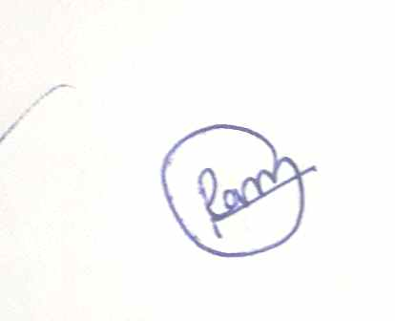
iz/kkukpk;Z
jkmekfo tkylw ukud

